DECISION SUPPORT ALGORITHMS FOR PORT-OF-ENTRY INSPECTION

Fred S. Roberts

DIMACS / Rutgers University
CoRE Building/4th Floor
Rutgers University
96 Frelinghuysen Road
Piscataway, NJ 08854-8018
froberts@dimacs.rutgers.edu

ABSTRACT

Finding ways to intercept illicit nuclear materials and weapons destined for the U.S. via the maritime transportation system is an exceedingly difficult task. Today, only a small percentage of ships entering U.S. ports have their cargoes inspected. We describe a project aimed at developing decision support algorithms for efficiently intercepting illicit materials and weapons. The algorithms seek to find inspection schemes that minimize total cost, including “cost” of false positives and false negatives.

We envision a stream of entities (containers) arriving at a port and a decision maker having to decide how to inspect them, which to inspect further, and which to allow to pass through. This is a complex sequential decision making problem. Entities are thought of as having attributes, each in a number of states. In the simplest case, we seek to classify entities into two categories (“ok” and “suspicious”), there are two states (“present” or “absent”), and the classification can be described as involving a boolean decision function (BDF). Different binary tree representations for a BDF have different inspection costs associated with them and we look for an efficient decision tree representation. Modeling sensors used to test for attributes makes the problem more realistic and brings in possible inspection errors and false positives and negatives. Extending the problem to more than two categories and more than two states also makes the problem more realistic.

Introduction

Finding ways to intercept illicit nuclear materials and weapons destined for the U.S. via the maritime transportation system is an exceedingly difficult task. Until recently, only about 2% of ships entering U.S. ports have had their cargoes inspected. The percentage at some ports has now risen to 6%, but this is still a very small percentage. We describe a project aimed at developing decision support algorithms that will help us to efficiently intercept illicit materials and weapons and to test the algorithms on data arising from port-of-entry inspections. The algorithms we seek will find inspection schemes that minimize total cost, including “cost” of false positives and false negatives. The project is in a preliminary stage and this paper describes the approach.

We envision a stream of entities (containers) arriving at a port and a decision maker having to decide how to inspect them, which to subject to further inspection and which to allow to pass through with only minimal levels of inspection. This is a complex sequential decision making problem. Sequential decision making is an old subject, but one that has become increasingly important with the need for new models and algorithms as the traditional methods for making decisions sequentially do not scale.

Existing algorithms for efficiently intercepting illicit cargo assume that sensor performance, operating characteristics of ports, and overall threat level are all fixed. The approach in this project involves decision logics and is built around problem formulations that lead to the need for combinatorial optimization algorithms as well as methods from the theory of boolean functions, queueing theory, and machine learning. Practical complications of any such approach involve economic impacts of surveillance activities, errors and inconsistencies in available data on shipping and import terminal facilities, and the tradeoffs between combinations of sensors. A full-blown approach to the port-of-entry inspection problem includes the decision problem of when to initiate different levels of inspection if there are seasonal variations in cargo flows and cargo types, sensor reliability effects, and changing threat levels. In general terms, it is necessary to explore new sensor deployment methods and sensor configurations, the problem of false alarms from naturally occurring radiation sources (which vary spatially) and from innocent cargos (such as medical waste), and models of “information sensors.” Moreover, existing algorithms for designing port-of-entry inspection are rapidly coming up against the “combinatorial explosion” caused by so many possible alternative inspection strategies. In this project, we are developing an approach that will ultimately address many of these complications.

Sequential Diagnosis

The problem we are studying belongs to a general class of sequential diagnosis problems. Such problems arise in many areas, including communication networks (testing connectivity, paging cellular customers, sequencing tasks, etc.), manufacturing (testing machines, fault diagnosis, routing customer service calls, etc.), artificial intelligence and computer science (optimal derivation strategies in knowledge bases, best-value satisficing search, coding decision tables, etc.), and medicine (diagnosing patients, sequencing treatments, etc.).

Formulating the Problem

One approach to this problem is based on the ideas of Stroud and Saeger [6] and has been applied at Los Alamos in initial formulations of the port-of-entry inspection problem as a problem in decision logic. We use the formulation of the problem in [6] to explain the issues and describe our approach. In this project, we are seeking efficient algorithms to solve a variety of variations of this problem.

Attributes and Classification Schemes

We have a set of entities to be inspected and classified according to observations we make. In the port-of-entry inspection application, these are containers being offloaded from ships. There are several categories into which we seek to classify entities. In the simplest case, these are positive and negative, 1 or 0, with 0 designating entities that are considered “ok” and 1 designating entities that raise suspicion and require special treatment. After each observation, we either classify the entity or subject it to another observation. A classification scheme or inspection scheme specifies which observations are to be made depending upon outcomes of previous observations.

Observations have costs associated with them, including costs of delays. So do assignments to the wrong category. If we have two categories, then the two types of misclassifications are false positives, classifying an entity as 1 when in fact it should be 0, and false negatives, classifying an entity as 0 when in fact it should be 1. We would like to design a classification scheme that minimizes total costs. Note that by including false positives and negatives in costs, we don't have to say “minimizes total costs while achieving an acceptable error rate.” The same abstract approach applies to decision making problems in a variety of applications, including medical, diagnostic, and surveillance situations. The overall goal of the project is to find algorithms that will produce classification schemes that minimize total costs.

To make the problem a bit more concrete, we assume that each entity has n attributes, a₀, a₁, ..., a_{n}, each in one of a number of states. In the case of port-of-entry inspections, the attributes might, for instance, be the levels of certain kinds of chemicals or biological materials or something simple like whether or not there are items of a certain kind in the cargo list or containers of certain sizes or shapes or whether the cargo was picked up in a certain port. The U.S. Customs Service has been inspecting for contraband shipments for a long time. However, we shall concentrate on inspections for nuclear weapons. The initial attributes of interest are: whether or not the ship's manifest sets off an alarm in the U.S. Customs Service “anomaly detection” programs; whether or not the container gives off neutron or Gamma emissions that are above some threshold; whether or not a radiograph image recognition test comes up positive; whether or not an induced fission test comes up positive. However, we can imagine many other types of attributes and we want to emphasize that our research is concerned with good systems in general, not necessarily ones tied to today's technology or methodology. Indeed, detectors are evolving quickly and new innovations are both leading to significant decreases in the costs of detectors and many new features as well.

For simplicity we shall assume that there are only two states, 0 and 1, say for concreteness representing the presence or absence of the attribute. Thus, an entity can be represented as a binary string of length n, e.g., 011001 if n = 6. The classification will be thought of as a decision function F that assigns to each binary string a category. In this project, we are concentrating at first on the case where there are two categories. Then, F is a boolean function. For instance, consider the boolean function defined by F(000) = F(111) = 1 and F(abc) = 0 otherwise. This is the function that classifies an entity as positive iff it either has none of the attributes or all of them. Boolean functions provide the selection logic for an inspection scheme.

In the simplest scenario, the boolean function F is known. A more complex problem is to infer the function F from observations. More on this below. If F is known, we seek to determine its value by testing the attributes one by one. In a typical case, the attributes are assumed to be independent. We shall return to the question of whether we know the distribution of the attribute states, in particular in the binary case the probability that the i^{th} attribute takes on the value 0. Once an entity is presented for inspection, we do not know the states of its attributes. An inspection scheme then tells us in which order to test the attributes. At any point, the inspection scheme might tell us to stop inspecting and output the value of F based on the outcomes of inspections so far. We must make enough observations to allow us to classify the entity and decide whether to designate it an item of interest or let it pass. The problem is to find a classification scheme that allows us to do this and minimizes the total cost.

There are several complications that arise and have been considered in the literature. The components may not be independent. (Thus, not all binary strings can arise as inputs to the function F.) There may be some precedence relations in the components. For example, suppose we can never test attribute a₄ before testing attribute a₆. Costs may depend on the components tested before. For instance, suppose that in checking a₅, the entity is taken apart or opened to some extent. Then testing a₆ after a₅ may become much simpler. Finally, F may depend on some variables that cannot be directly tested or, what is equivalent, the costs of doing those tests may be excessively large. Thus, in this case, some misclassification will necessarily occur.

Several simplifying assumptions have been widely considered in the literature and will be useful here. For instance, we might be interested only in inspection schemes in which a₁ is always tested before a₂. Also, F might belong to a special class of functions.

Almost all of the sequential diagnosis problems that arise using such a formulation are very hard computationally. There are many possible boolean functions F that could be used. Indeed, with n attributes, there are $2^{2^{n}}$ possible boolean functions. Even if F is fixed, the problem of finding a good classification scheme, which we shall define below as the problem of finding an optimal binary decision tree for F, is NP-complete [4]. Most of these sequential diagnosis problems have an inherent double exponentiality: The best strategy in fact depends on both F and its dual F^{d}(x) = $\overline{F}$($\overline{x}$), where $\overline{F}$ = 1 – F and the vector $\overline{x}$ is obtained from x by complementing each of its components; and the derivation of F^{d} in itself may be exponential in the input. Then, the best inspection scheme may be reflected in an optimal binary decision tree the finding of which is exponential in both the sizes of F and its dual (see e.g. [3]). Several classes of functions F have been found for which both difficulties can be overcome and an efficient inspection scheme is possible. This is the case for k-out-of-n systems, certain series-parallel systems, read-once systems, “regular systems,” and Horn systems. Even under precedence constraints, there are some easy cases. We are looking for other such examples.

Another approach is to look for efficient heuristics and test these heuristics on data. For so-called coherent systems, there are already some results (see e.g. [1]). We shall seek to modify several of these approaches.

Sensors and Inspection Lanes

Let us suppose that there are n types of sensors that can measure the presence or absence of the n attributes. In practical applications, we will have many copies of each sensor. At first, we are assuming that all sensors for measuring attribute a_{i} have the same characteristics. Later, we shall define these characteristics in terms of power and costs of purchase and operation. An alternative point of view is that we really only have one characteristic we are inspecting for, but we have n different kinds of sensors that are used to make observations, each kind with its own characteristics in terms of power and costs. We present our approach using the language of attributes.

As entities come for inspection, we need an algorithm to decide which type of attribute to test for in which order and then we need an algorithm to decide which of the sensors of a given type to use to test an entity. We think of “inspection lanes” and entities queueing up on an inspection lane to test for attribute a_{i}. At some stage in the process, we decide we have tested enough to label an entity as category 0 or “ok” and let it go, or label it as category 1 or “not ok” and subject it to extensive further examination. Besides designing an efficient classification scheme, there are other ways to minimize costs: buy more sensors, re-design our allocation process of entities to sensor lanes, etc. We discuss this part of the problem below.

Binary Decision Tree Representation

One approach to the problem that we are investigating is to think of a classification scheme as a directed acyclic digraph and, in the case of two categories, a binary tree or binary decision tree (BDT). Each node of the tree represents either a sensor or a category and is labeled with the attribute being measured by the sensor or the number of the category to which it corresponds. The category nodes are the leaves of the tree and the scheme ends once we reach a category node. Two arcs exit from each sensor node, each labeled left or right. During our classification (inspection), we take one of these, the right hand one, when the sensor tells us the corresponding attribute is present, and the other when the sensor tells us it is not. The arcs may lead to another sensor node or to a category node. Once we reach a category node, we classify the entity being inspected as belonging to that category.

For instance, consider the three binary trees of Figures 1,2,3. In Figure 1, we reach category 1 from the root only through the path a₀ to a₁ to 1. Thus, we classify an entity into category 1 iff it has both attributes. Thus, the binary decision tree corresponds to the Boolean function F(11) = 1, F(10) = F(01) = F(00) = 0. Figure 2 corresponds to the same Boolean function. In Figure 3, we reach category 1 from the root either through the path a₀ to 1 or a₀ to a₁ to 1 and classify an entity into category 1 iff it has attribute a₀ or attribute a₁. The corresponding boolean function is F(11) = F(10) = F(01) = 1, F(00) = 0.

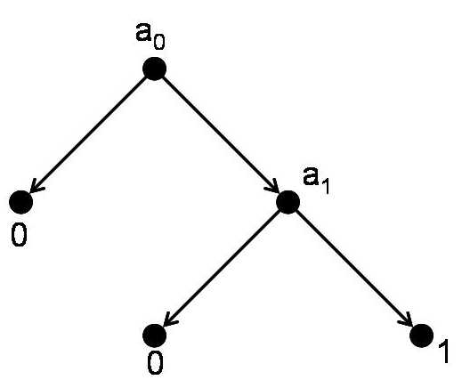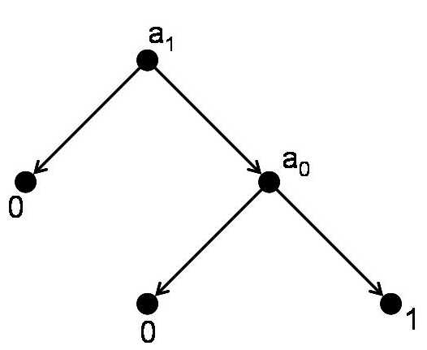

Figure 1: A BDT corresponding to F(11) = 1, F(10) = F(01) = F(00) = 0.
Figure 2: A BDT corresponding to the same boolean function as that of Figure 1.

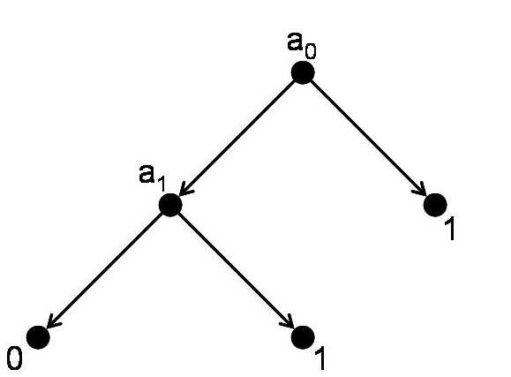

Figure 3: A BDT corresponding to F(11) = F(10) = F(01) = 1, F(00) = 0.

Consider the binary tree given in Figure 4. Here, we reach category 1 from the root either through the path going left from a₀ to a₁, right from a₁ to a₂, and right from a₂ to 1, or through the path going right from a₀ to a₂ and right from there to category 1. In other words, we classify an entity into category 1 iff (i) it has attributes a₁ and a₂ but not a₀ or (ii) it has attributes a₀ and a₂ and possibly a₁. Thus, the binary decision tree corresponds to the boolean function F that assigns 1 to binary strings 111, 101, and 011, and 0 to others.

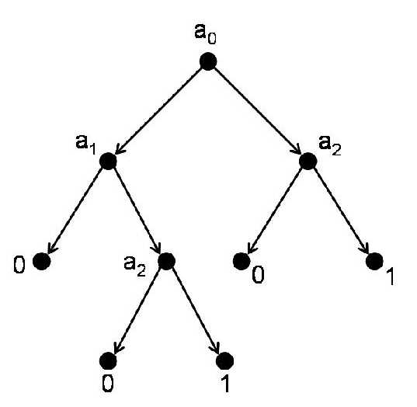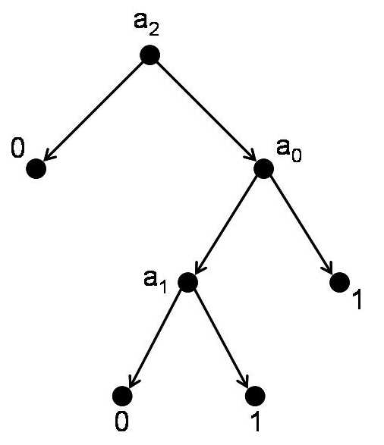
Figure 4: A BDT corresponding to F(111) = F(101) = F(011) = 1, F(x₁x₂x₃) = 0 otherwise.
Figure 5: A BDT corresponding to the same boolean function as that of Figure 4.

Consider now Figure 5. The binary decision tree here calculates the same boolean function. However, it has one less observation node a_{i}. Thus, if we disregard the possibility of sensor errors and the related cost of false positives and false negatives and assume that all tests of attributes are equally costly, the binary decision tree of Figure 5 provides a more efficient classification scheme for this Boolean function than that of Figure 4.

As we observed earlier, the problem of finding an efficient classification or inspection scheme is difficult because there are so many boolean functions and so many binary decision trees that can be used in inspection schemes that represent such functions. Indeed, as we also observed, even if the boolean function F is fixed, the problem of finding the optimal BDT for it is NP-complete. If the number n of attributes is small, as it is in today's port-of-entry inspection schemes, then one could try to enumerate all binary decision trees for n attributes and use brute force methods to find the least expensive scheme. For n = 4, Stroud and Saeger [6] show that this approach is feasible, at least if we limit ourselves to BDTs that enumerate special types of boolean functions. However, as they observe, even for n = 4, there are already too many possibilities to have an algorithm that enumerates the BDTs in a practical way. That is a major part of the motivation for exploring alternative algorithmic approaches. The case n = 5 is not unrealistic since it is the number being considered in port-of-entry inspections in such places as the Port of Long Beach-Los Angeles. So, it would be useful to see if alternative algorithms might be able to push the Stroud-Saeger methods further to achieve some solutions for this case, at least under some additional special assumptions such as those discussed above. However, it is clear that more sophisticated algorithms will be needed if there are even a modest number of attributes. If we allow the function F to vary or be only partially defined, then the problem becomes even more complex. Because the number of possible BDTs that correspond to a given boolean function is so large, it might make more sense to find one that only approximates the function rather than implements it in all cases. We return to this idea below.

Our approach to the problem of finding an optimal BDT corresponding to a given boolean function builds on a large literature from a variety of fields, in which many special cases of the problem have already been considered. Our main problem appears in AI as part of rule-based systems, where inductive trees are one of the main tools in rule-based learning. In computer science, the problem is really central, since circuit complexity is essentially the depth of a BDT representing a function F. Of course, in computer science, the main emphasis in the literature has been worst case results, which is not necessarily useful for finding a particular representation of a special kind of given function F. Nevertheless, the circuit complexity literature will be useful to us to understand theoretical limits and possibly the structure of tractable instances. Special cases, called “satisficing search,” and search strategies in theorem proving, are also essentially equivalent to our problem. In reliability theory, many special cases of the problem fall under the rubric of the “diagnosis problem.” It is sometimes called the “quiz show problem” since quiz shows involve decisions about choosing a next category, or whether to stop or continue a process. In the theory of programming/databases, the conversion of decision tables into “if-then-else” structures also involves similar problems.

Errors in classification occur if we have the wrong boolean function (and therefore are looking for a BDT that implements the wrong decision rules) or if the sensors can make mistakes. At first, we are assuming that the sensors are error-free. Below, we discuss generalizations where sensors can make errors.

Increasing Binary Strings and Monotone Boolean Functions

In many applications, we can choose attributes so that the observation that an entity has an attribute increases the likelihood that the entity belongs to the category 1 while the observation that it does not have an attribute decreases this likelihood. Thus, an entity represented as 111...1 has the highest probability of being in category 1 and, generally, an entity with binary string x₁x₂...x_{n} is more likely to be in category 1 than an entity with binary string y₁y₂...y_{n} if x_{i}  y_{i} for i = 1, ..., n. This gives us a partial order of the binary strings that can sometimes be useful. A boolean function F for which F(x₁x₂...x_{n})  F(y₁y₂...y_{n}) in this circumstance is called monotone. Even if monotonicity fails, we can use the partial order to limit the number of binary strings on which we must define F in order for F to be defined on all binary strings. We will investigate ways to do this.

A boolean function F on n variables is incomplete if F can be calculated by finding at most n-1 attributes and knowing the value of the input binary string on those attributes. For instance, the function F(111) = F(110) = F(101) = F(100) = 1, F(000) = F(001) = F(010) = F(011) = 0 is incomplete since F(abc) is determined without knowing b (or c). We call a boolean function feasible if it is monotone and complete. Limiting our problem to feasible boolean functions will cut down considerably on the number of possible classification schemes (binary decision trees) we need to consider. However, incomplete boolean functions could have significantly smaller BDTs and less expensive corresponding classification schemes. We return to this point below.

Stroud and Saeger [6] provide an algorithm for enumerating the binary decision trees that implement a given feasible boolean function. If there are two attributes (n = 2), there are six monotone boolean functions, but only two of these are feasible: F(11) = F(10) = F(01) = 1, F(00) = 0, and F(11) = 1, F(10) = F(01) = F(00) = 0. There are four binary decision trees for calculating these two feasible boolean functions. (Figures 1 and 2 define the two binary decision trees for the second of these.) Stroud and Saeger calculate that with 5 attributes, there are already 6894 feasible boolean functions and 263,515,920 corresponding boolean decision trees. We will investigate alternative algorithms for generating binary decision trees that implement a feasible boolean function. A monotone BDT is a BDT corresponding to a monotone boolean function. A promising heuristic approach to develop a monotone BDT fitting a given set of observations was introduced in [2]. In case the monotone function F is completely defined, a “best” monotone BDT depends on both F and its dual F^{d}. It is well-known that F^{d} can be obtained efficiently from F in the monotone case, and thus the problem of finding a “best” BDT for F can be formulated as an integer programming problem. Another approach we plan to explore is based also on an explicit description of both F and F^{d}, and on a numerical evaluation of their prime implicants.

Cost Functions for Sensor Observations

The port-of-entry inspection problem involves three kinds of costs: costs of making observations, costs of false positives, and costs of false negatives. There are many possible ways to calculate the cost of obtaining a sensor reading. Indeed, this too may have several components such as unit cost, delay cost, and fixed cost. The unit cost is just how much it costs to use it to inspect one item, the fixed cost is the cost of the purchase and deployment of the sensor itself, and the delay cost is the cost that arises from queues that build up while we are scheduling items to be inspected. In many cases, the primary cost is the unit cost since many inspections are very labor intensive. In our first formulation, we are disregarding the fixed and delay costs and are simply seeking BDTs that minimize or come close to minimizing the unit costs. We are looking for algorithms to find the optimal or near-optimal solutions if we have a given number of entities to inspect. At first, the approach is completely disregarding the characteristics of the population of entities being inspected and concentrating simply on the number of observation (attribute) nodes in the binary decision tree, which is a well-known problem. Later, however, we will also want to consider how many nodes in this decision tree are actually visited in classifying a given entity. This will force us to make an assumption about the distribution of entities having different binary string attribute representations. Even with just the goal of minimizing unit costs, the problem now becomes more complex.

There is a tradeoff between fixed costs and delay costs. Obviously, adding more sensors to check for attribute a_{i} will cut down on the delays caused by backups at such sensors. Suppose we fix some value for the cost of an hour's delay. (We assume that whether the delay is at one type of sensor or another is irrelevant, though sensors for measuring different types of attributes might have different delay characteristics.) Models taking this tradeoff into account will involve fixed costs calculated using the daily amortized capital cost of a sensor divided by the number of objects per day that are classified, following [6]. To analyze delays, we need to model a stochastic process of entities arriving and also a distribution of delay times for an inspection. We will investigate several models of such processes and use queueing theory methods to find average delays under different assumptions.

The models for sequential decision making often assume that error costs are known. But what if there is uncertainty in error costs? In machine learning, this problem is widely studied under the name “reinforcement learning” and we shall study the extent to which the reinforcement learning approaches apply to the port-of-entry inspection problem.

Costs of False Positives and False Negatives

Measuring the cost of false positives is relatively straightforward. The cost here is the cost of additional tests. In practice in port-of-entry inspection, these additional tests can mean opening up the container and inspecting its contents manually. This is very costly in comparison to the unit cost of tests such as neutron or Gamma emissions detection since it might involve several workers for several hours.

Measuring the costs of false negatives using units that are commensurable with units used to measure other costs will be a challenge for the project. We will approach this using methods of utility theory and measurement theory [5].

In diagnostic situations, an ROC curve provides a useful graphical representation of the tradeoff between the false negative and false positive rates for every possible cutoff. In some situations there is, as in our problem, a resource limitation on the number of tests that can be performed. Then it may be possible to select an operating point on the ROC curve in terms of this constraint, rather than by the slope. The problem is then reduced to designing the screening system so that the ROC curve meets the resource line as close as possible to the ideal point.

Sensor Errors

Sensors can make incorrect observations as to whether an entity has an attribute. In the simplest model that takes this into account, we will simply assume that all sensors that check for attribute a_{i} have a fixed probability of saying the attribute is present when it is not and another of saying it is not present when it is. Our first analysis will start with this type of assumption.

However, considering the ways in which we use sensors can lead to a more realistic analysis. Sensors have different discriminating power when testing for a given attribute. Most methods currently in use in port-of-entry inspection are based on counts, e.g., Gamma radiation counts. In this case, we conclude that an attribute is present if the counts exceed a certain threshold. Following [6], let us model sensor errors by assuming that each sensor for attribute a_{i} has a discriminating power K_{i} and threshold setting T_{i}. We will assume that readings of category 0 entities follow a certain distribution and similarly category 1 entities. In [6], each is a Gaussian distribution and we will make a similar assumption. We will assume that the mean reading of a category 1 entity on an attribute a_{i} sensor will exceed that of a category 0 entity by some factor that depends on K_{i} and will also make some assumption in terms of K_{i} about the standard deviation of such readings for both category 0 and 1 entities. Given the values of K_{i} and T_{i}, we will seek to calculate the fraction of category 0 entities and of category 1 entities whose readings exceed the threshold T_{i}. We will allow the thresholds to vary and will seek threshold values that assist in minimizing total cost. To minimize total cost, we assume we can vary both thresholds and number of sensors of each kind. The latter, of course, reflects the tradeoff between capital cost and delay cost. We will run simulations to determine classification schemes, threshold levels, and numbers of sensors of different kinds to minimize total costs. Stroud and Saeger [6] report on runs on some test cases to find optimal binary decision trees, for instance with four attributes. We hope to improve on these results for small values of n.

Setting the threshold of a sensor is very different if it is to be used alone as opposed to when it is a part of a collection of sensors. Relevant approaches to the more complex problem of setting thresholds in the latter case are found in the work of various authors. Setting thresholds when data for the sensors is costly to obtain is also an intriguing problem that we would like to investigate further.

Extensions of the Work to More Complex Problems and Other Approaches

In addition to following the approach we have outlined above, we plan to gradually weaken some of the assumptions and to explore some quite different approaches to the port-of-entry inspection problem.

One direction to investigate is the situation where an attribute can have more than two possible states or that where there are more than two categories. For instance, we might have states like
“present,” “absent,” “present with probability at least 75%,” absent with probability at least 75%,” “uncertain”; or categories like “ok,” “not ok,” “ok with probability at least 99%,” “ok with probability between 95% and 99%.”

We have assumed that the boolean function F is known. A more complex problem is to infer the function F from observations. We will study the problem of finding a “best” (cost/time optimal) monotone BDT agreeing with a given incomplete set of observations.

Much of the literature on port-of-entry inspection algorithms concentrates on optimal schemes for implementing a boolean decision function F. However, there might be much more efficient classification schemes if we don't insist on implementing F exactly and instead concentrate on approximation.

As we have noted, the problem of finding an optimal BDT for a given boolean function is NP-complete. Sometimes the problem is easier for special function classes. For instance, in electrical engineering, this is a part of circuit synthesis. Here, a more economic representation called a binary decision diagram (BDD) has been developed that is appropriate for the EE applications and is typically sparse in some sense, and this allows for a more efficient algorithmic approach. One of the goals of our work will be to investigate whether something similar might work in the port-of-entry inspection context.

In situations when sensors are not available to test for some of the attributes, we might look to create “super-attributes” that are logical combinations of the original attributes. The same approach might help to reduce the dimensionality of the problem.

Machine learning methods can be helpful when we have to construct the decision function or decision tree from observations. We will investigate such methods in the port-of-entry inspection application. In particular, we will explore Bayesian binary regression models, growing BDTs through learning with “splitting,” and using pruning to reduce the size of the decision tree by reducing redundancy or irrelevant or inconsistent rules that might have been found in the tree-growing process.

Testing our Models: Data

To formulate, parametrize, and test our models, we will access data made available to us by our partner researchers at Los Alamos. Much of this data comes from port-of-entry inspections in the port of Long Beach - Los Angeles. While there are similarities between ports, all ports are different. For example, compared to Long Beach – Los Angeles, the port of Newark handles many different materials and containers and handles ships from different origins. One of our goals will be to examine available data and use it to help us design models and methods that will be transferable from one type of port to another.

Some of the data we expect to analyze simply involves operating characteristics of the inspection terminal, e.g., layout, which will help us in model formulation. Data about container flow over a period of months will be very helpful. Performance data will help us analyze error rates.

One key question is that since much of the available data will pertain to containers that it was decided to open, there would be a biased sample. How this will skew our results is a subject for analysis.

Los Alamos maintains an unclassified database on all smuggling attempts that have been interdicted world-wide and our partners will provide us access to this data as well. It will be useful in testing our models and heuristics.

When real data is not available, we will use a simulator to generate it. There is a good simulator for the types of data we would find useful that is used at Pacific Northwest National Laboratory
(see http://www.pnnl-software.com/synth/home.htm). Here, data for our study can be generated by computer simulation under various conditions of absorbers, shielding, dosages, spectral masking etc. Another such simulator is available at Sandia.

References

[1] A. Biasizzo, A. Zuzek, and F. Novak, “Enhanced sequential diagnosis,” in J.W. Sheppard and W.R. Simpson (eds), Research Perspectives and Case Studies in System Test and Diagnosis, Kluwer Academic Publishers, 1998.

[2] E. Boros, T. Ibaraki, and K. Makino, “Monotone extensions of Boolean data sets,” Proceedings of 8th International Workshop on Algorithmic Learning Theory, vol. 1316 of Lecture Notes in Artificial Intelligence, Springer-Verlag, Berlin, pp. 161-175, 1997.

[3] M.R. Garey and R.L. Graham, “Performance bounds on the splitting algorithm for binary
testing,” Acta Informatica, vol. 3, pp. 347-355, 1974.

[4] L. Hyafil and R.L. Rivest, “Constructing optimal binary decision trees is NP-complete,” Information Processing Letters, vol. 5, pp.15-17, 1976.

[5] F.S. Roberts, “Limitations on conclusions using scales of measurement,” in S. Pollock, A. Barnett, and M.H. Rothkopf (eds), Operations Research and the Public Sector, Elsevier, Amsterdam, pp. 621-671, 1994.

[6] P.D. Stroud, P.D. and K.J. Saeger, “Enumeration of increasing boolean expressions and alternative digraph implementations for diagnostic applications,” in H. Chu, J. Ferrer, T. Nguyen, and Y. Yu (eds), Proceedings Volume IV, Computer, Communication and Control
Technologies: I, International Institute of Informatics and Systematics, Orlando, FL, pp. 328-333, 2003.

Acknowledgements

The author thanks the Office of Naval Research for its support under grant number N00014-05-1-0237 to Rutgers University. He also thanks Los Alamos National Laboratory for its support and collaboration. The author also gratefully acknowledges the members of the project team: From Rutgers University: Endre Boros, Elsayed Elsayed, Paul Kantor, Alexander Kogan, David Madigan, Richard Mammone, and S. Muthukrishnan; from Los Alamos National Laboratory: Sallie Keller-McNulty, Feng Pan, Richard R. Picard, Kevin Saeger and Phillip Stroud; and from the University of Medicine and Dentistry of NJ: Paul Lioy.

