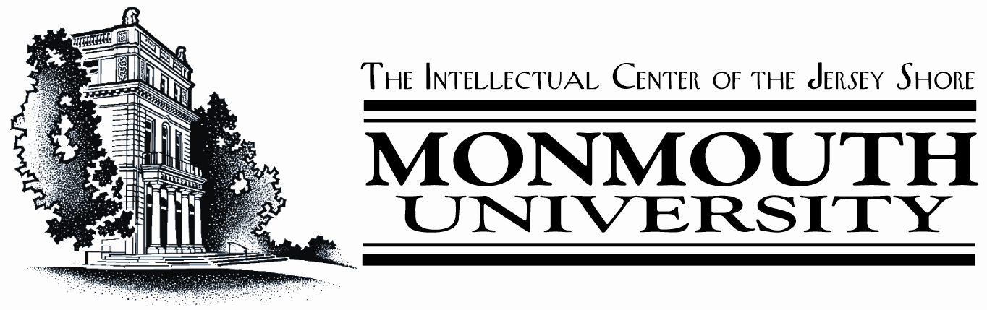

4th STATEWIDE SYMPOSIUM ON HOMELAND SECURITY
“Leveraging Research Collaborations and Partnerships to meet New Jersey’s Homeland Security Needs”
Hosted by
Monmouth University
School of Science, Technology and Engineering
with the support of the Center for Rapid Response Database Systems

May 23, 2005
Registration Form

NAME: __________________________________________

Affiliation: ________________________________________
Address: __________________________________________
__________________________________________

Contact Information: Phone: ________________________
Fax: __________________________
e-mail: _______________________

Box Lunch Choices: Baked Ham and Swiss ( )
(Check your choice) Roast Beef & Provolone ( )
Marinated Grilled Vegetables ( )
Tuna Salad ( )

Send Registration to: Barbara Reagor, Monmouth University
FAX: 732-923-4770 or e-mail breagor@monmouth.edu
BY MAY 18, 2005

