






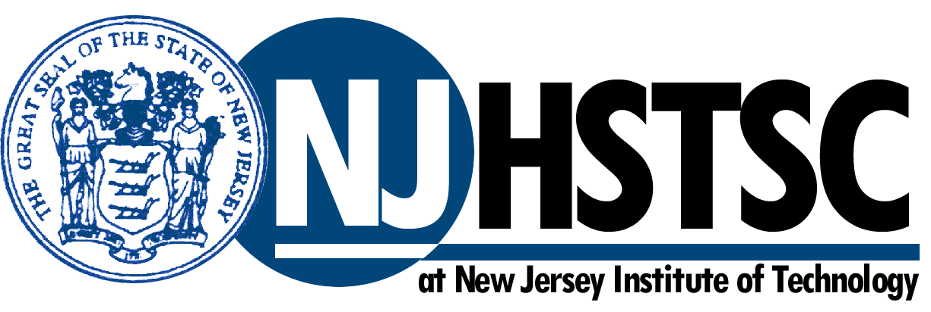
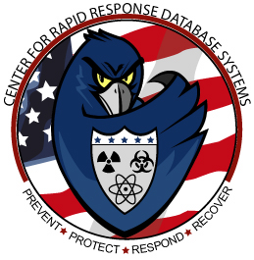



FIFTH STATEWIDE SYMPOSIUM ON HOMELAND SECURITY
Featuring
“Emergency Preparedness and Response”
Sponsored by
NJ Universities Consortium on Homeland Security
Hosted by
NJIT & NJ Homeland Security Technology Systems Center

Tuesday, November 29th, 2005
8:30 AM – 3:30 PM
Hazel Ballroom, NJIT
University Heights, Newark, NJ

Focus Area Panel Sessions
Collaborative & Interdisciplinary Environments
Emergency Communications Systems
Software Systems Integration and Interoperability
Training & Training Technologies
Luncheon Key Note Address
NYC Police Commissioner Bernard Kerik (ret)
Vendor Displays
Poster Sessions

