6th New Jersey Universities Homeland Security
Research Consortium Symposium

Sponsored by Fairleigh Dickinson University

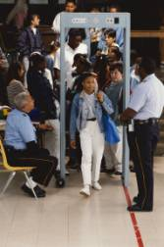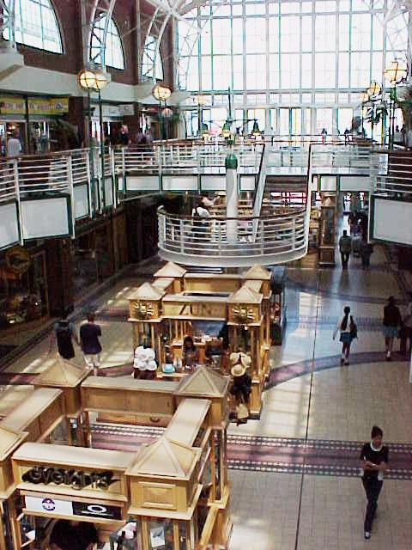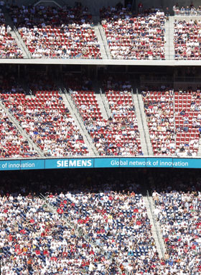

Symposium Themes: Increasing School Security, Mall and Sporting Event Security

Location: Dickinson Hall, Wilson Auditorium, Fairleigh Dickinson University
Date/ Time: Monday, May 15, 2006 - 9 AM - 3:00 PM
Speakers:

Keynote: Jan H. Gilhooly, Protection Security Advisor, Department of Homeland Security

Sporting event security: Vincent Bove, Summit Security Services
Gen. Edward C O’Connor (ret.), Advisor, Homeland Intelligence
Technologies, Inc.

Mall security: Lt. Jim Sheehan, Paramus Police Department
General William Marshall (ret.), NJIT

School Security Panel 1:
“What can and should university Researchers to help with precollege school security?” Discussion moderated by Fred Roberts (Rutgers)
Panelists: Andrew Bland (DOE), Drew Harris (UMDNJ), Barbara Reagor (Monmouth)
James R. Smith (UMDNJ)

School Security Panel 2: Industrial Panel on School Security
Kenneth Bruno (K.A.B. Systems), Vincent Bove (Summit Security), Ed Petersen (Buckley and Petersen Associates)

Posters and Vendors: There will be an area where school security technology and demonstrations of academic and military research related to security will be displayed. A limited amount of posters will be accepted for the lobby area. Please send your poster in MS Word format, or your request to be a security research exhibitor or vendor to Dr. Eamon Doherty Doherty@fdu.edu for consideration.

Registration: Please contact Chris Ellen Cunningham with your point of contact details at cec@fdu.edu to register for the event. There is no cost. However, advance registration is strongly requested so we can get an adequate count for number of attendees. Light refreshments and lunch will be served.

Directions: Parkway North to Route 4 East, Hackensack Avenue Exit,
Please go approx. ½ mile, turn left at Boston Market and go down the street. Parking instructions: http://www.fdu.edu/visitorcenter/directions/teaneck_map.html

Program Committee: Eamon Doherty (FDU), Brig. Gen. (ret) William Marshall (NJIT), Lew Meixler (Princeton Plasma Physics Lab), Fred S. Roberts (Rutgers University)

